###### Hui Lab

A computer vision system is used to track the stroke volume of a microfluidic valve, which is approximately 1 µL. This system processes the frames of a video and outputs data on volume versus input pressure. The data from this experiment is currently in the process of being published. The provided MATLAB files are shown as a code sample and do not represent the complete set required for full functionality.

**Fig H1**. Single frame to be analyzed by computer vision.

The blue line will move when the input pressure to the valve is changed.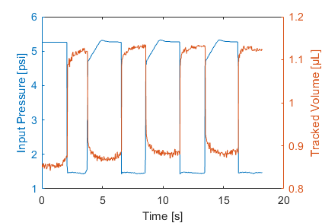

**Fig H2**. Input pressure vs output stroke volume of the microfluidic valve over time.

4 samples at ~5.2 psi are shown here

###### Bowman Lab

* Developed a MATLAB library(Circuit class) to model Electrical Impedance Spectroscopy (EIS) data
* Simply put, EIS inputs an AC voltage at different frequencies and observes the AC current through a given material to find its impedance characteristics. The data is commonly shown as a Nyquist plot of the impedance.
* Library can fit EIS data to any given EIS model
* The main plotting script is YSZ8_EIS_Plotting.m
* The fitting script is YSZ8_EIS_Fitting.m
* The Circuit Class is used for fitting

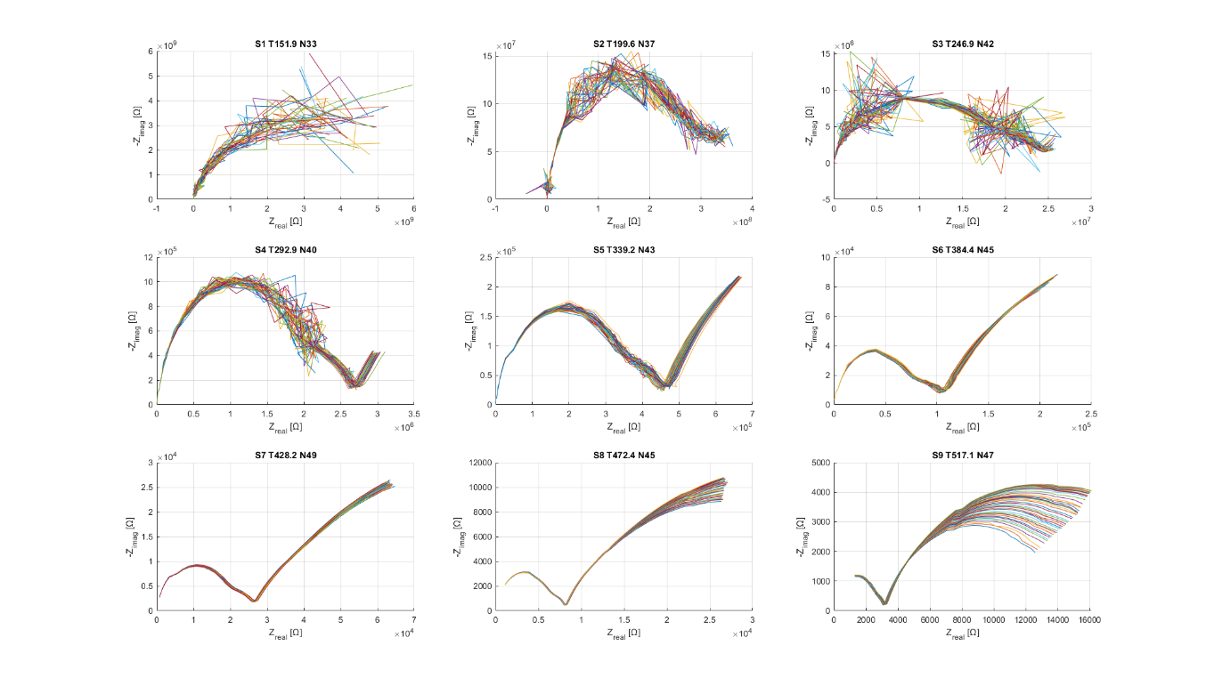

**Fig B1**. Raw EIS data

* (Fig B1) Raw data from 9 series (S) at different temperatures (T), with number of samples (N)

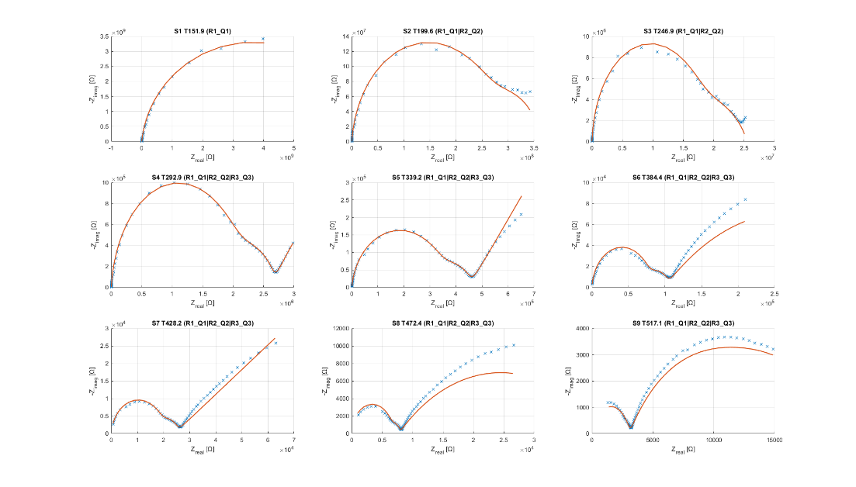

**Fig B2**. Fitted EIS data

###### MAE 52 Project

* A Front loader construction vehicle was created
* The video highlights an animation of the loading mechanism

<https://www.youtube.com/watch?v=pa-znrugPwM>

###### Hui Lab Microfluidics PCB

<https://easyeda.com/bxlam/test-1_copy>

* This was a PCB created for the Hui Lab to aid in Microfluidics testing
* Runs on 24V input for up to 32 addressable solenoids, 4 pressure sensors controlled by an Arduino Mega
* Buck converter to step down power to 12 V for Arduino
* Includes 3 I2C lines, 1 CANBUS line for external interfaces

**Fig HP1**. Microfluidics PCB Schematic

**Fig HP2**. Microfluidics PCB trace pattern